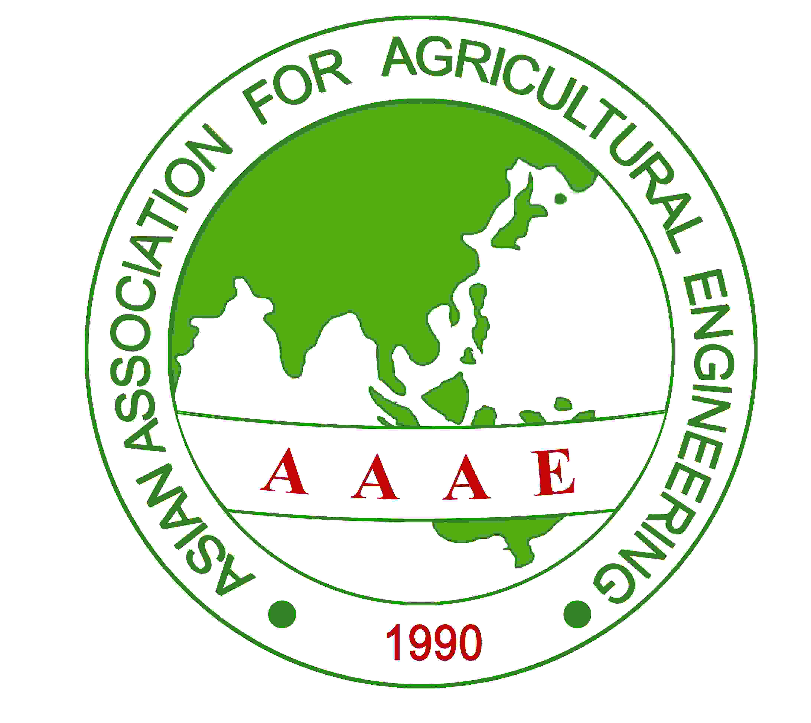 | ASIAN ASSOCIATION FOR AGRICULTURAL ENGINEERING (AAAE)  C/O Aspee Agricultural Research Foundation, Village, Bhiwali, Taluka Bhiwandi, Dist. Thane 401 206, Maharashtra, INDIA

MEMORANDUM OF UNDERSTANDING

THIS AGREEMENT of Mutual Understanding made between
ASIAN ASSOCIATION FOR AGRICULTURAL ENGINEERING (AAAE, https://aaaesociety.org) having Registered Office at Thane- 401206, India and hereinafter called “PARTY OF THE FIRST PART (AAAE)” and _______________ _____________________________________________ having Office at: ____________________________________________________________________________________________________________________________, Here in after called “PARTY OF THE SECOND PART (______)”.

- WHEREAS the main objective of the Party of the First Part (AAAE) is to strengthen the profession of Agricultural Engineering by promoting information exchange, improving communications and optimizing use of resources and to formulate and promote voluntary academic, professional and technical standards of relevance to the profession of Agricultural Engineering in Asia and to support at the international level the activities of National Agricultural Engineering Societies or related associations and to maintain liaison among them as a Consortium.
- WHEREAS the Party of the Second Part (_______) has evinced interest to collaborate with AAAE as a member of the Consortium, therefore both the parties have agreed to record the Guidelines for a Consortium which will govern their future joint activities by executing this Memorandum of Understanding.

NOW THIS AGREEMENT WITNESSETH AS FOLLOWS:
a). AAAE shall promote the activities of National Society in international forums by means of publications like newsletters, magazines, and news feeds in community networks.
b). AAAE shall assist in international participation and organizing of National conventions, conferences, and exhibitions.
c). AAAE shall coordinate evaluation and framing of standards for systems of Agricultural Machinery and Technology, for better adaptation in the region.
d). AAAE shall bridge cooperation between Agro based Industries in the region for better cooperation, transfer of technology and business opportunities.
e). AAAE shall liaison with National government agencies for promotion of Agricultural Engineering profession and Agroindustry for sharing and better utilization of resources of member countries.
f). AAAE shall conduct as well promote national collaborative programs, classes, webinars, competitions for the students of member countries to get international experience in research and agricultural practices.
g). AAAE shall constitute awards to researchers and industry to help promote sustainable and collaborative research and develop products that benefit the farmers in the region.
h). AAAE shall liaison with international agencies for funding and other assistance for collaborative projects between researchers of the member countries.
i). The National Association shall cooperate and provide resources to assist AAAE in the above stated objectives and activities.
j). The National Association shall offer discounted fee structure for its conferences, conventions, publications to life members of AAAE member country associations as well as AAAE.
k). The National Association shall provide possible logistics as well resource support to AAAE members participating in their events and activities.

This document is executed in duplicate and is retained by both parties.

The authorized representatives of both parties hereto have put their signatures on this Agreement of Mutual Undertaking with dates as below.

Name of the Association: ASIAN ASSOCIATION FOR AGRICULTURAL ENGINEERING (AAAE)
Signature :

Full Name : Prof. Indra Mani Logo
Position : Secretary General
Date :

____________________________________

Name of the National Association:
Signature :

Full Name : Logo

Position :
Date :
_______________________________

